University of Canberra

Faculty of Science and Technology

**Programming for Data Science G (11521)**

**Week 5 Tutorial**

**List, Tuple and Assignment 1**

**Tasks**

* To learn List and Tuple
* To apply List and Tuple to Assignment 1 to display data samples and cluster centres.

**Create a new Python project**

* Create **Week5Tutorial** project (Python)
* Add a module file and name it **io_data_module.py**
* There are 13 examples for List and 9 examples for Tuple in Week 4 Lecture
* Review those examples before you answer the questions below.

**Questions: Write Python code in Week5Tutorial.py for each question below**

* **Question 1**: Create a list of 100 elements like this [0, 1, 2, 3, 4, …, 99]
* **Question 2**: Create a tuple of 100 elements like this (0, 1, 2, 3, 4, …, 99)
* **Question 3**: Change values of input_list from string to number and output as output_list
  + input_list = ['2.1', '3.5', '4.8', '1.1', '2.0']
  + output_list = [2.1, 3.5, 4.8, 1.1, 2.0]
* **Question 4**: Change each element **x** in a list to **x / sum** where sum is total of all elements in that list. For example, mylist = [0, 2, 1, 3, 1, 2, 0, 1] and sum = 0+2+1+3+1+2+0+1 = 10 and mylist becomes [0.0, 0.2, 0.1, 0.2, 0.3, 0.2, 0.0, 0.1]
* **Question 5**: Remove the first and last elements from a list. For example, my_list = ['red', 0, 2, 1, 1, 2, 0, 1, 'blue'] becomes my_list = [0, 2, 1, 1, 2, 0, 1]
* **Question 6**: Change 0 to 10 in [0, 1, 0, 2, 0, 1] to have [10, 1, 10, 2, 10, 1]
* **Question 7**: Combine list1 and list2 to have list3, list4 and list5 as follows
  + list1 = [2, 3, 1]
  + list2 = [4, 5, 2]
  + list3 = [2, 3, 1, 4, 5, 2]
  + list4 = [[2, 3, 1], [4, 5, 2]]
  + list5 = [(2, 3, 1), (4, 5, 2)]
* **Question 8**:
  + Write a function (**read_multi_dim_data**) in **io_data_module.py** that reads data from **iris.data** file and outputs a list of tuples where each tuple is a data sample.
  + Write a program in **Week5Tutorial.py** that calls the **read_multi_dim_data** function to print out all 150 data samples. Below is example for the first 8 lines

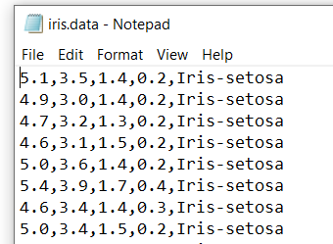 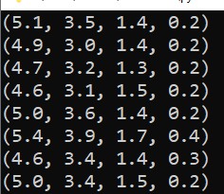

For more information on the **iris** data set

* + Each line contains 4 real numbers and a string. The 4 numbers form a 4-dimensional data sample and the string is class label (the term ‘class’ here is for data classification, it’s not class in Python object-oriented programming).
  + There are 3 classes (Iris-setosa, Iris-versicolor, and Iris-virginica) in the Iris dataset.
  + There are 50 data samples in each class.
  + All 150 data samples are in 4-dimensional data space.
* **Question 9**: Write a Python program in **Week5Tutorial.py** that
  + reads all 150 data samples in **iris.data** and displays them on canvas using the function developed in Question 8 above, where **x** and **y** are the **first** and **second** values in each data sample, respectively, and
  + displays 3 centre samples centre_1 = (5.1, 3.0, 1.1, 0.5), centre_2 = (4.4, 3.2, 2.8, 0.2), and centre_3 = (5.7, 3.9, 3.9, 0.8) on the same canvas with the **iris.data** data samples as seen below where red dots are iris data samples and black dots are centres.

